**Comcast Telecom Consumer Complaints**

1. **Import data into R environment.**

Code :-

#Importing Dataset

dataset <- read.csv(file.choose())

1. **Provide the trend chart for the number of complaints at monthly and daily granularity levels.**

Code:-

#Processing Date

install.packages('lubridate')

library(lubridate)

dmy(dataset$Date) ->dataset$Date

#Extracting Monthly and Daily Ticket Count

install.packages('dplyr')

library(dplyr)

monthly_count<- summarise(group_by(dataset,Month =as.integer(month(Date))),

Count = n())

daily_count<- summarise(group_by(dataset,Date),Count =n())

monthly_count<-arrange(monthly_count,Month)

#Comparing Monthly and Daily Complaints

#_____________

library(ggplot2)

#1-Monthly

ggplot(data = monthly_count,aes(x=Month,y=Count,label = Count))+

geom_point(size = 1)+

geom_line()+

geom_text()+

scale_x_continuous(breaks = monthly_count$Month)+

labs(title = "Monthly Ticket Count",x= "Months",y ="No. of Tickets")+

theme(plot.title = element_text(hjust = 0.5))

#2-Daily

ggplot(data = daily_count,aes(x=as.POSIXct(Date),y=Count))+

geom_line()+

geom_point(size = 1)+

scale_x_datetime(breaks = "1 weeks",date_labels = "%d/%m")+

labs(title = "Daily Ticket Count",x= "Days",y ="No. of Tickets")+

theme(axis.text.x = element_text(angle = 75),

plot.title = element_text(hjust = 0.5))

Outpute:-

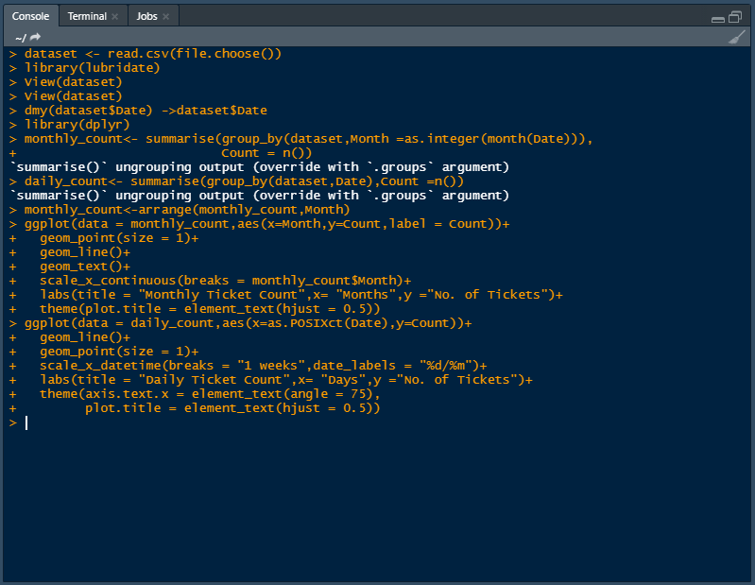

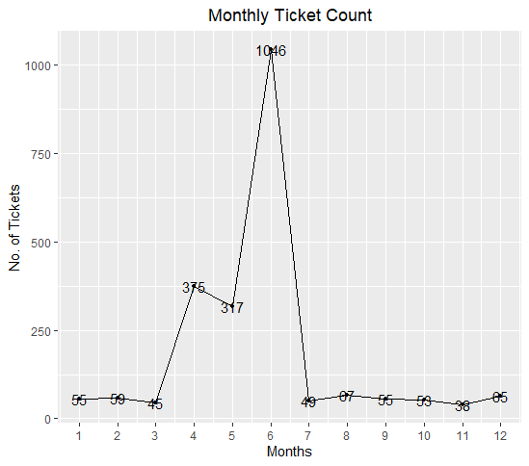

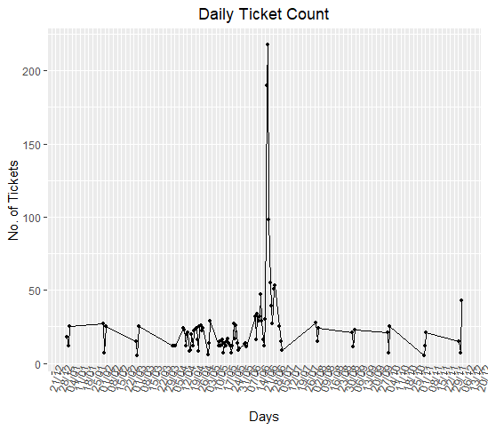

1. **Provide a table with the frequency of complaint types**

Code:-

#Complaint Type Processing

network_tickets<- contains(dataset$Customer.Complaint,match = 'network',ignore.case = T)

payment_tickets<- contains(dataset$Customer.Complaint,match = 'payment',ignore.case = T)

billing_tickets<- contains(dataset$Customer.Complaint,match = 'bill',ignore.case = T)

email_tickets<- contains(dataset$Customer.Complaint,match = 'email',ignore.case = T)

charges_ticket<- contains(dataset$Customer.Complaint,match = 'charge',ignore.case = T)

speed_ticket<- contains(dataset$Customer.Complaint,match = 'speed',ignore.case = T)

service_ticket<- contains(dataset$Customer.Complaint,match = 'service',ignore.case = T)

dataset$ComplaintType[payment_tickets]<- "payment"

dataset$ComplaintType[network_tickets]<- "Network"

dataset$ComplaintType[service_ticket]<- "service"

dataset$ComplaintType[billing_tickets]<- "Billing"

dataset$ComplaintType[email_tickets]<- "Email"

dataset$ComplaintType[charges_ticket]<- "Charges"

dataset$ComplaintType[speed_ticket]<- "speed"

dataset$ComplaintType[-c(payment_tickets,network_tickets,

billing_tickets,charges_ticket,

email_tickets,speed_ticket,

service_ticket)]<- "Others"

table(dataset$ComplaintType)

Outpute :-

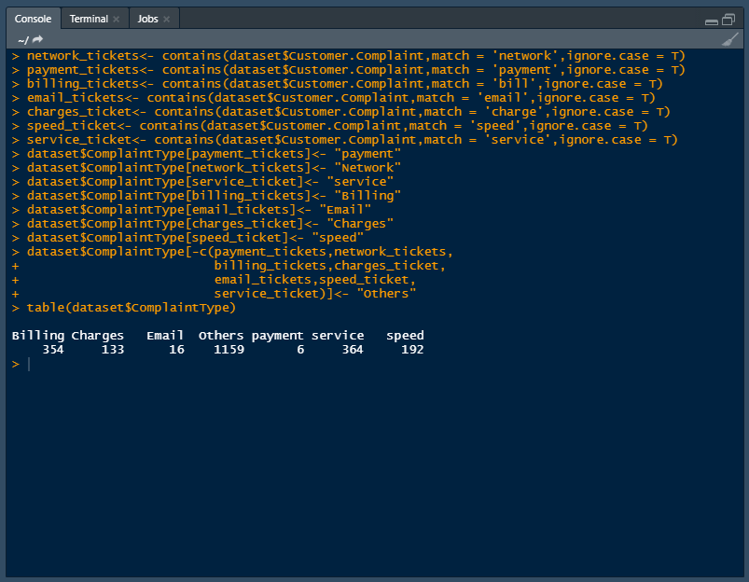

1. **Which complaint types are maximum i.e., around internet, network issues, or across any other domains.**

* **Create a new categorical variable with value as Open and Closed. Open & Pending is to be categorized as Open and Closed & Solved is to be categorized as Closed.**
* **Provide state wise status of complaints in a stacked bar chart. Use the categorized variable from Q3. Provide insights on:**

Code:-

#Creating new Variable ComplaintStatus with values Open and Closed

open_complaints<- (dataset$Status == "Open"| dataset$Status =="Pending")

closed_complaints<-(dataset$Status == "Closed"| dataset$Status =="Solved")

dataset$ComplaintStatus[ open_complaints]<-"Open"

dataset$ComplaintStatus[closed_complaints]<- "Closed"

#Creating Stacked barchart for complaints based on State and Status

dataset<- group_by(dataset,State,ComplaintStatus)

chart_data<- summarise(dataset,Count = n())

ggplot(as.data.frame(chart_data) ,mapping = aes(x=State,y=Count))+

geom_col(aes(fill = ComplaintStatus),width = 0.95)+

theme(axis.text.x = element_text(angle = 90),

axis.title.y = element_text(size = 15),

axis.title.x = element_text(size = 15),

title = element_text(size = 16,colour = "#0073C2FF"),

plot.title = element_text(hjust = 0.5))+

labs(title = "Ticket Status Stacked Bar Chart ",

x = "States",y = "No of Tickets",

fill= "Status")

#Finding State which has Highest number of Unresolved Tickets

chart_data%>%

filter(ComplaintStatus == "Open")->

open_complaints

open_complaints[open_complaints$Count == max(open_complaints$Count),c(1,3)]

Outpute :-

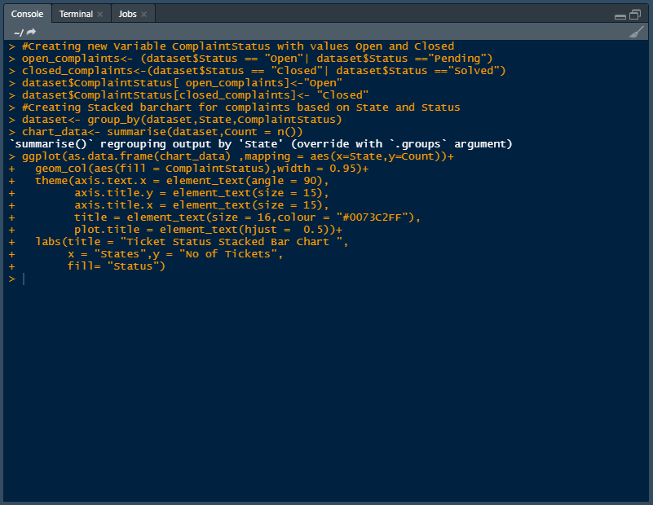

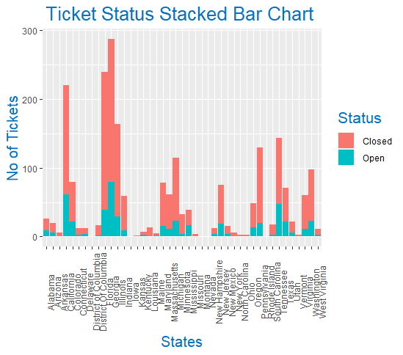

it`s clearly shown that the highest number of complaints recorded from the state Georgia and the second highest number of complaints recorded from the state Florida

1. **Which state has the maximum complaints**

Code:

#Finding State which has Highest number of Unresolved Tickets

chart_data%>%

filter(ComplaintStatus == "Open")->

open_complaints

open_complaints[open_complaints$Count == max(open_complaints$Count),c(1,3)]

Outpute:-

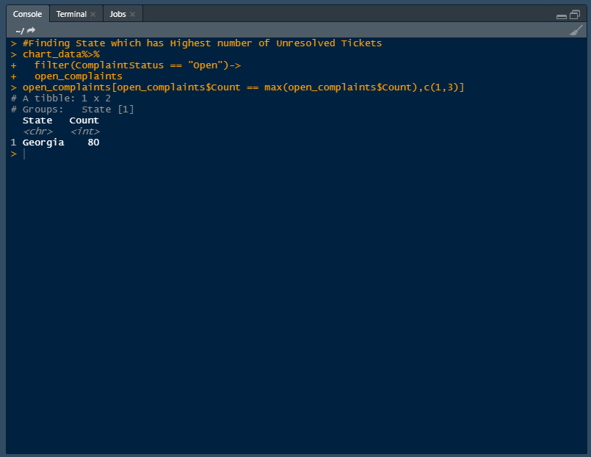

As we can observe that State Georgia has maximum number of unresolved tickets and these ticket count is 80.

1. **Provide the percentage of complaints resolved till date, which were received through theInternet and customer care calls.**

Code:-

#Calculating Resolution Percentage based on Total and Catagory

resolved_data <- group_by(dataset,ComplaintStatus)

total_resloved<- summarise(resolved_data ,percentage =(n()/nrow(resolved_data)))

resolved_data <- group_by(dataset,Received.Via,ComplaintStatus)

Category_resloved<- summarise(resolved_data ,percentage =(n()/nrow(resolved_data)))

#Ploting Pie Chart for Total Resolved Vs Category Resolved

install.packages("ggpubr")

library(ggpubr)

par(mfrow = c(1,2))

total<-ggplot(total_resloved,aes(x= "",y =percentage,fill = ComplaintStatus))+

geom_bar(stat = "identity",width = 1)+

coord_polar("y",start = 0)+

geom_text(aes(label = paste0(round(percentage*100),"%")),

position = position_stack(vjust = 0.5))+

labs(x = NULL,y = NULL,fill = NULL)+

theme_classic()+theme(axis.line = element_blank(),

axis.text = element_blank(),

axis.ticks = element_blank())

# Pie Chart for Category wise Ticket Status

category<-ggplot(Category_resloved,

aes(x= "",y =percentage,fill = ComplaintStatus))+

geom_bar(stat = "identity",width = 1)+

coord_polar("y",start = 0)+

geom_text(aes(label = paste0(Received.Via,"-",round(percentage*100),"%")),

position = position_stack(vjust = 0.5))+

labs(x = NULL,y = NULL,fill = NULL)+

theme_classic()+theme(axis.line = element_blank(),

axis.text = element_blank(),

axis.ticks = element_blank())

ggarrange(total,category,nrow = 1, ncol = 2)

Outpute:-

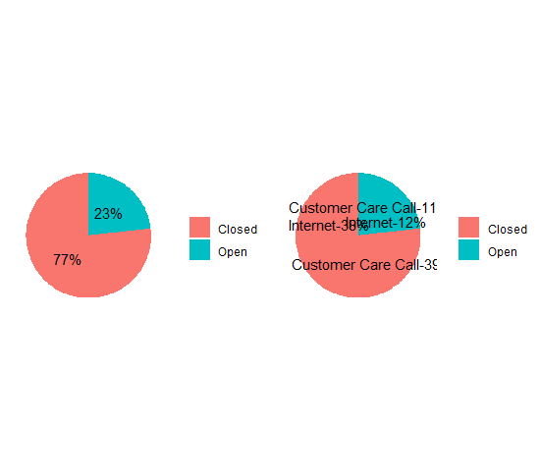

With the help of above Chart of Total Resolved Vs Category Resolved we can conclude that the total resolved complaints are 77% in which 38% are received the internet and 39% are from the customer care calls.Also we can obserse that there are 23% complaints are still unresolved and in which 12% are received the internet and 11% are from the customer care calls